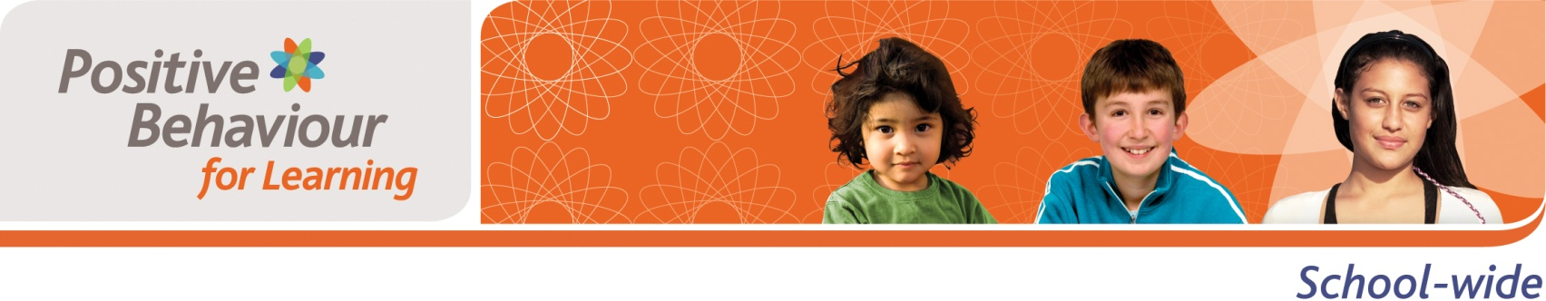

Positive Behaviour for Learning School-Wide (PB4L-SW) Training Readiness Survey for Staff

Name (optional):__________________________________________________________________

School: _________________________________________________________________________

Complete | Is there a need for PB4L School-Wide in your School?
- YES NO | - Do you believe your school would benefit from PB4L School-Wide?
- YES NO | - Do you agree to be an active participant in PB4L School-Wide implementation?
- YES NO | - Are you interested in being on the leadership team to facilitate the implementation of PB4L School-Wide in your school?

